**Automatic quantification of multiple positions images in Fluocell**

**Download**

Download the quanty module and its related data into parallel folders, which are “quanty/” and “data/quanty_sample/”.

**Part 1, Sort files:**

Before processing the images, you need to sort the image files for each position into separated folders and so that Fluocell and MATLAB can recognize and process the images:

1. Path of the data folders:

>> p = 'D:/sof/data/quanty_sample/'; % You can copy the path directly. Remember to add a forward slash at the end of the path string.

1. Pass subfolder name to MATLAB parameter, make the folder names as simple as possible for MATLAB recognitions:

>> sub_dir = {'1-Cyto-Fyn_Cbl(wt)_PDGF/', 'other_subfolder_name/'}; % Remember to add a forward slash after subfolder name.

1. Run the function in MATLAB:

>> batch_sort_file_multiple_position(p, sub_dir);



**Part 2, Quantification for multiple positions:**

|  |  |
| --- | --- |
|  |  |
|  |

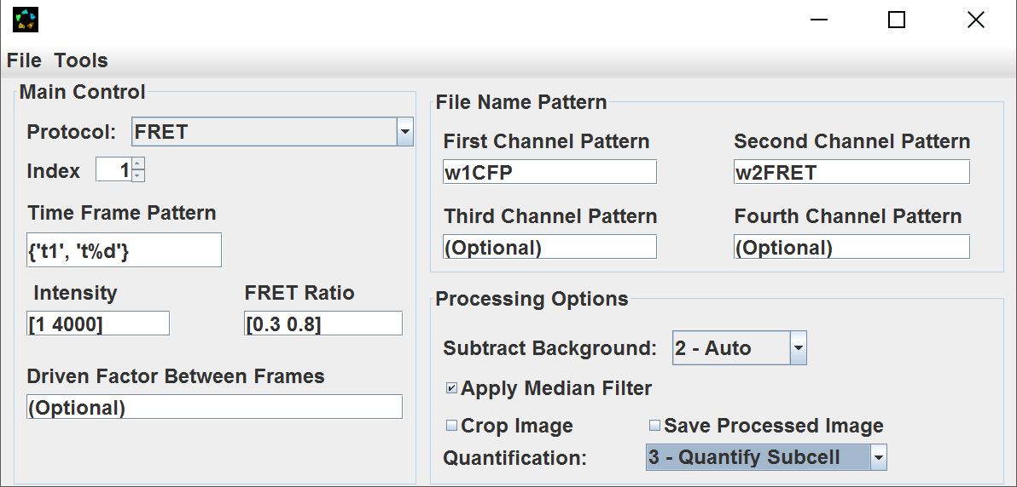

1. Change all the channel pattern names to be right under “File Name Pattern”, for the sample data, w1CFP and w2FRET. For some special situation, you might deal with other kind of biosensor and you want the ration to be FRET/CFP, here you need to adjust the first channel to be FRET image and the second channel to be CFP image;
2. Select “Subtract Background 🡪 2 - Auto”, “Apply Median Filter”, and “quantification: 🡪 3 – Quantify Subcell”. If you want to check ratio images later, select “Save Processed Image”. The last selection is only recommended for single position quantification, not for all positions, since it will greatly slow down the analysis process.
3. In command window,

>> fluocell_data.num_layers = 3;

1. Go to “Tools” in Fluocell, and input “BrightnessFactor” value to be 1.0 and you can also choose “Show Detected Boundary” if you want to see the detection.
2. Use Fluocell to open the FRET Ratio image file in p1/. Carefully check how many time points you have. Go to “Tools” in Fluocell and choose “Batch Update Image”, input the index as format: [1:24], say 24 is the number of time points (frames) you have in your file (No need to click the “OK” button).
3. After that, check the pdgf information and go to MATLAB command window.

>> fluocell_data.pdgf_between_frame = [5; 6];

This means the stimulation (pdgf) is added at cycle 6. For example, if you add your pdgf at cycle *n*, you set the fluocell_data.pdgf_between_frame to be [n; n+1];

1. Passing the data in fluocell to MATLAB:

>> group = g2p_init_data(fluocell_data, 'group_data',[]);

In MATLAB, you will see the following output.

g2p_init_data: Update from fluocell_data since there is no input of group data or the data file.

g2p_init_data: Please make sure that fluocell is reading images from the p1 position.

pdgf time = 643.100000 sec

1. Quantification of multiple positions:

>> g2p_quantify(group, 'num_layers', 3);

You can adjust the number of layers here to other values.

|  |  |
| --- | --- |
|  |  |

1. Plot group result together:

>> group_plot(group,'method',3, 'save_excel_file', 1, 'sheet_name', 'quanty', 'y_limit', [0.5 2.5]);

* Output time and ratio sequence for inspection (default : normalized ratio);
* Save the time-ration excel for statistics;
* By setting the “y_limit” or “t_limit”, you can specify x or y-axis range, respectively;
* You should adjust “sheet_name” here to be your experiment data name, for example (‘sheet_name’, ‘MEF_src’)
* Output the cell-size to an excel file named “cell-size.xls”;

|  |  |
| --- | --- |
| A | B |

**Part 3, group comparison, view images, and make movies.**

How to use the excel file generated in part 2 to compare groups:

First, we need to add another group to the excel file by repeating parts 1 and 2 for another group called “dish2”.

>> group = g2p_init_data(fluocell_data, 'group_data', []); % load from saved file

>> g2p_quantify(group, 'num_layers', 3);

>> group_plot(group,'method',3, 'save_excel_file', 1, ...

'sheet_name', 'dish2', 'y_limit', [0.5 2.5]);

Open the result.xls file in the data folder to confirm that there are two sheets “quanty” and “dish2”. Remove all other sheets from the exel file, save and exit.

In MATLAB command window,

>> group_compare(group);

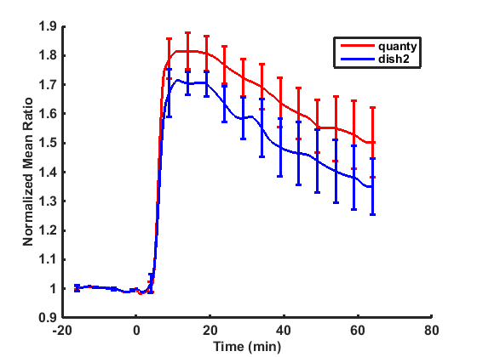

>> group_image_view(group, 'time_point', [-5; 30], 'num_col', 3);

|  |  |
| --- | --- |
|  |  |

The following commands make a move saved in the file “dish2\p1\output\FRET.avi”.

>> group.data.intensity_bound = [1 1000];

>> group_make_movie(group);**Part 4, special handling**

How to inspect specific position after quantification  
we still use “g2p_quantify” function here but with more parameter input. If you want to check if the tracking and detection are right for one specific position, for example you want to check position 3, you could use following function:

>> group = g2p_init_data(fluocell_data, 'group_data', [], 'name', 'p3');

If the quantification starts with other position, for instance, position 3.

>> g2p_quantify(group, 'show_figure', 1, 'num_layers', 3, 'name_i', 'p3');

or

>> g2p_quantify(group, ‘show_figure’, 1 (default value is 0 and you cannot see the tracking with 0), ‘num_layers’, 3, (decreased the influence from nucleus, 3 layers ) ’name_i’, ‘p3’ (detecting the specific position we are interested in ));